**FORMAN CHRISTIAN COLLEGE**

**(A CHARTERED UNIVERSITY)**



**Embedded Systems (CSCS 306)**

**FALL-2019**

**LAB-05**

**Staircase Light Control System**

**Group Members:**

* Mohammad Usman 20-10558
* Haris Naseer 20-10612
* Abeer Butt 20-10596

**Introduction:**

The aim of the lab was to test our skills in dealing with an LDR & PIR Motion Sensor and interfacing them with Arduino. It tested our coding skills, basically our logic in dealing with the value returned by LDR and using it to control an LED. This lab consists of only one LabTask.

**LabTask:** In this LabTask, we had to detect motion using the PIR Motion Sensor, then based on the ambient light sensed by the LDR, our code decides whether or not to turn on the LED (representing a light fixture). If it’s dark and motion is detected, then the LED remains on for at least 30 seconds. It remains on for 30 seconds more if motion is detected during this period. If no motion is sensed, the code turns the LED off.

**Working Code:**

**LabTask:**

const int led = 3; // the pin that the LED is attached to

int state = LOW; // by default, no motion detected

const int pir = 2; // the pin that the pir sensor is attached to

int pirVal = 0; // variable to store the pir sensor value

const int ldr = 0; // the pin that ldr is attached to

int ldrVal = 0; // variable to store the ldr value

void setup()

{

// put your setup code here, to run once:

Serial.begin(9600); // initialize serial

pinMode(led, OUTPUT); // initialize LED as an output

pinMode(pir, INPUT); // initialize sensor as an input

pinMode(ldr, INPUT); // initialize ldr as an input

}

void loop()

{

// put your main code here, to run repeatedly:

pirVal = digitalRead(pir); // read sensor value

ldrVal = analogRead(ldr);

Serial.print("LDR: ");

Serial.println(ldrVal);

if (pirVal == HIGH && ldrVal < 100) // check if the sensor is HIGH

{

if (state == LOW) // previously no motion was detected

{

Serial.println("Motion detected!");

state = HIGH; // update variable state to HIGH

digitalWrite(led, HIGH); // turn LED ON

func(); // call func which detects for further motion while LED is on

digitalWrite(led, LOW); // turn LED OFF

}

}

else

{

digitalWrite(led, LOW); // turn LED OFF

if (state == HIGH) // previously motion was detected

{

Serial.println("Motion stopped!");

state = LOW; // update variable state to LOW

}

}

}

void func()

{

unsigned long starttime = millis();

unsigned long endtime = starttime;

unsigned long delaytime = 30000;

int count = 0;

while ((endtime - starttime) <= delaytime) // do this loop for up to 1000mS

{

pirVal = digitalRead(pir); // read sensor value

if (pirVal == HIGH)

{

if (state == LOW) // previously no motion was detected

{

if (count < 1)

{

delaytime += 30000;

Serial.println("Motion detected again! 30 secs increased");

count += 1;

}

state = HIGH; // update variable state to HIGH

}

}

else

{

if (state == HIGH) // previously motion was detected

{

Serial.println("Motion stopped!");

state = LOW; // update variable state to LOW

}

}

endtime = millis();

}

}

**Circuit Diagram:**

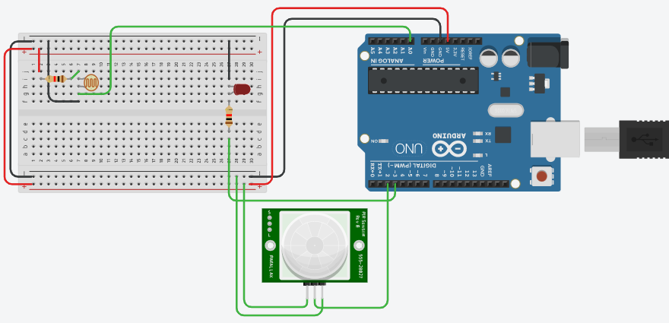

**Running Project Image:**

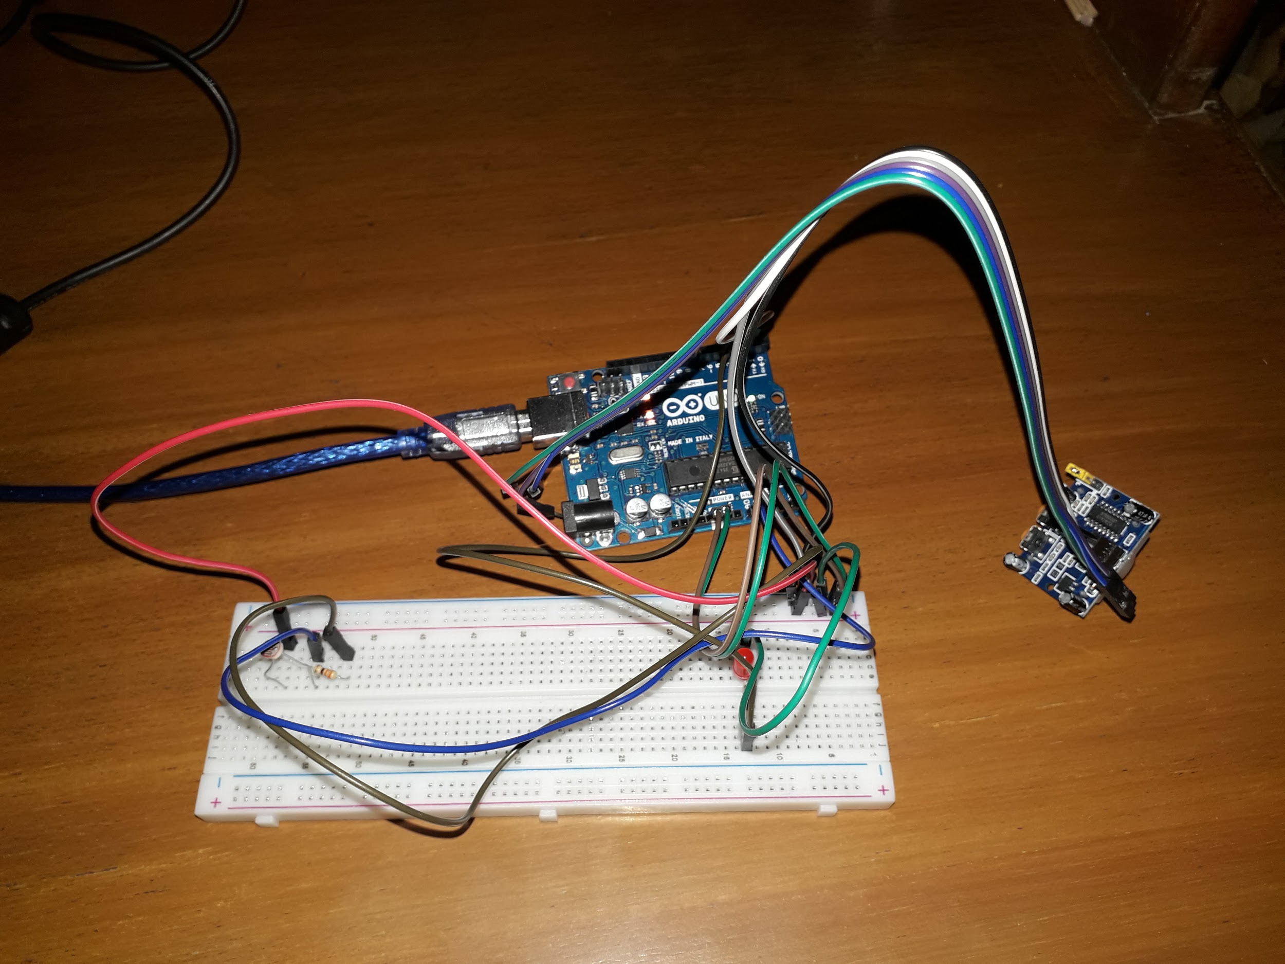

**Running Program Screenshots:**

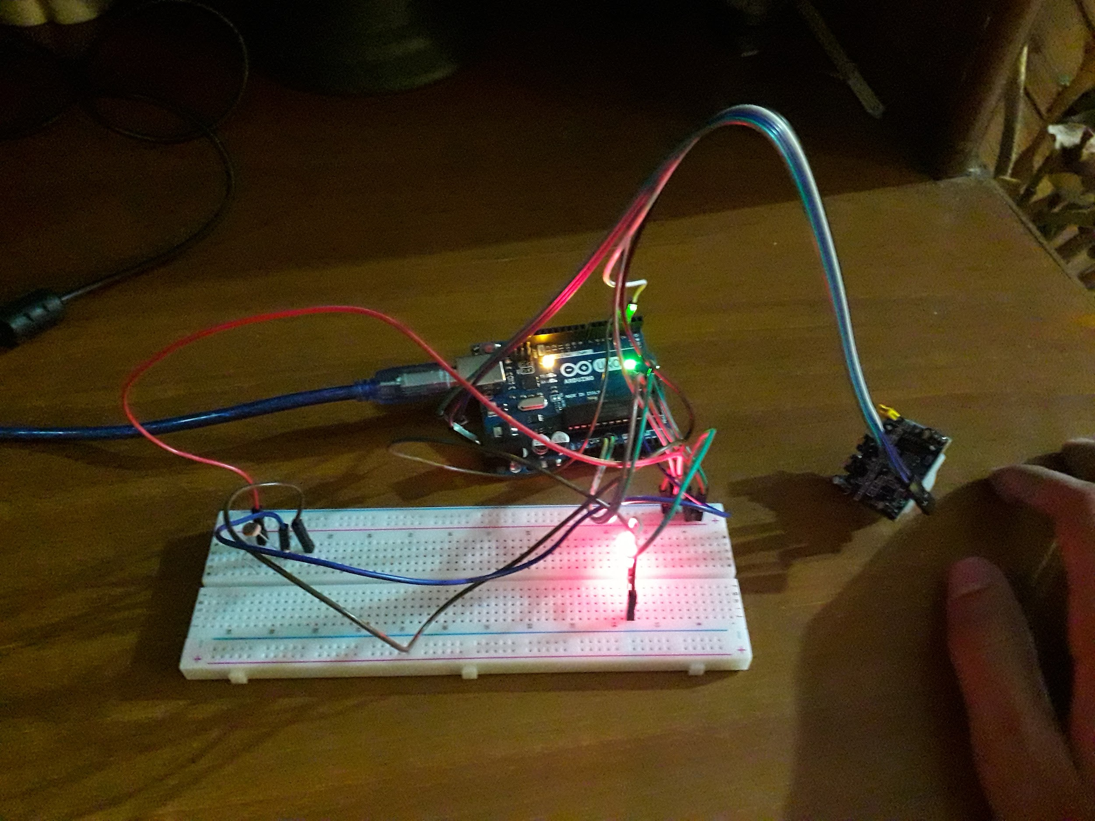

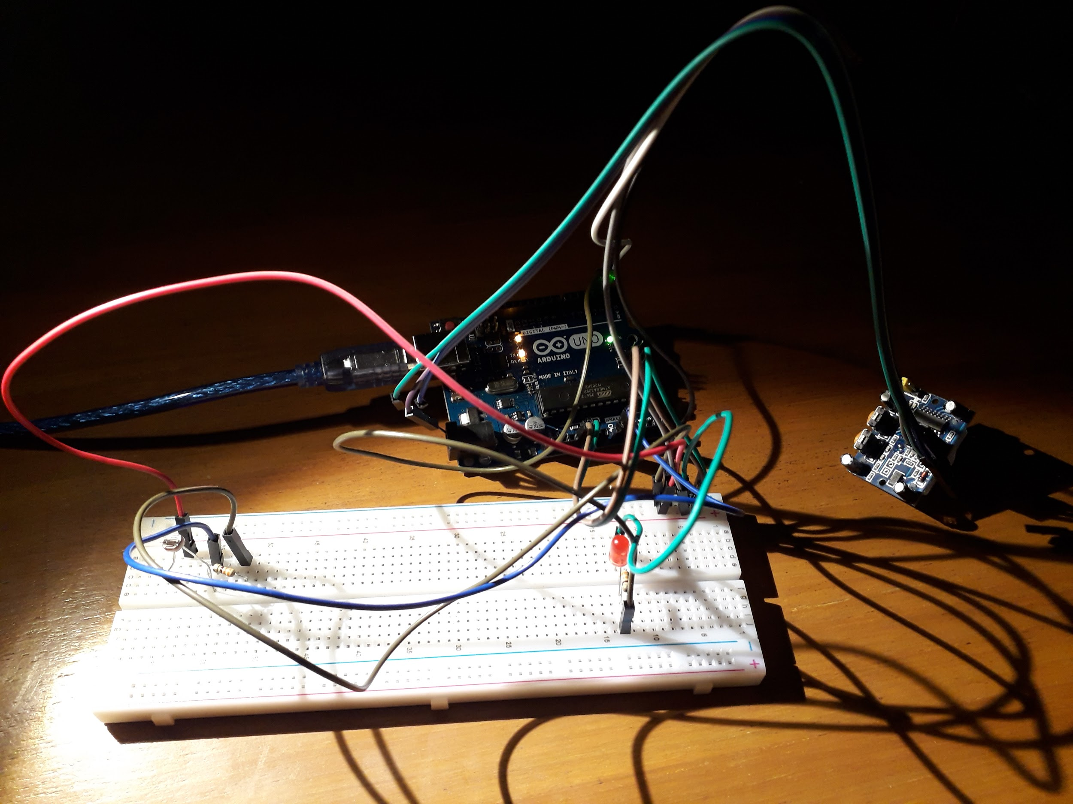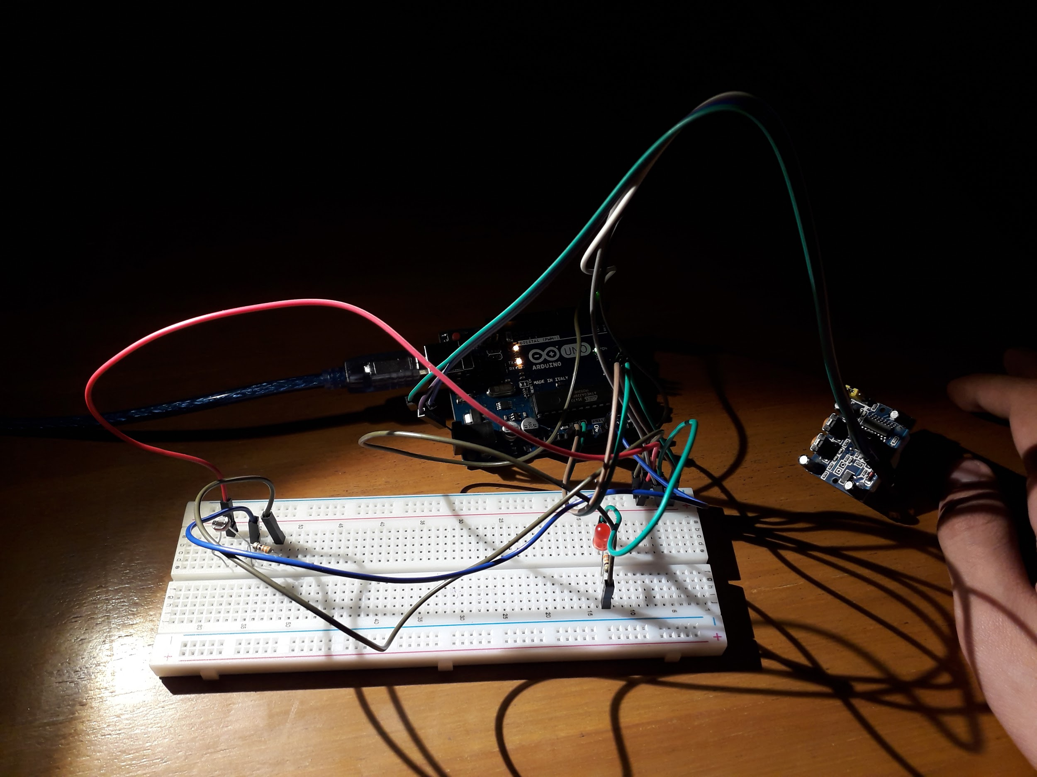

**References:**

* <https://www.arduino.cc/reference/en/language/functions/communication/serial/println/>
* <https://learn.adafruit.com/adafruit-arduino-lesson-2-leds/blinking-the-led>
* <https://maker.pro/arduino/tutorial/how-to-use-an-ldr-sensor-with-arduino>
* <https://randomnerdtutorials.com/arduino-with-pir-motion-sensor/>
* <https://www.tinkercad.com>